ART 3392-001: Visual Culture & Creativity

May Intersession 2025 –Syllabus

Instructor Information

Instructor
Lucy Bartholomee, Ph.D.

Office Number
FA 283

Office Telephone Number
(817) 272-2810 (Art Office)

Email Address
lucy.bartholomee@uta.edu

Faculty Profile
Lucy Bartholomee

Office Hours
Before & after class, and by appointment.

Course Information

Section Information
ART 4392-001: Special Studies, Visual Culture & Cretivity

Time and Place of Class Meetings
May 12-27, 2025; MTWRF 1:00-4:45 pm
FA 2105A and two field trips to Fort Worth museums.
Modality: In person.

Note: Two field trips to Fort Worth museums and galleries are scheduled. Students must provide their own transportation or we can organize a rideshare.
Prerequisites: Passing grades for studio art foundation classes (at least 1 must be completed before taking this class).

Description of Course Content

Understanding and communicating with others through visual art is fundamental to the study of art and art making. Students in this course will analyze aesthetic principles of contemporary imagery and artwork, including media, processes, techniques, and meaning. Developing your awareness of creativity as an experience and as a process is an important feature of this course. During class we will have several activities to enhance your understanding of how creativity functions in your own practice. Students will respond creatively to these concepts, then generate a series of three major artworks expressing concepts related to contemporary visual and material culture.

Technology Requirements
A laptop or access to a desktop computer is needed for this course. Assignments, reading material, assignment details and rubrics, all come through Canvas. Some assignments will be submitted on Canvas. The UTA library often has laptops that can be checked out if needed.

Student Learning Outcomes

1. Students will investigate and analyze visual aspects of life and culture that are involved in day-to-day life, media, and wide-ranging artistic works.

2. Students will examine key aspects of creativity, then analyze and reflect upon their own creative process.

3. Students will research and critique contemporary artwork, public events involving artwork, and artmaking practices related to themes and topics in the course, with opportunities for writing and creative expression.

4. Students will demonstrate a developing ability to act as knowledgeable professionals through dialogue and engagement with peers about art and visual experiences.

5. Students will design and create compelling artwork in a visual response to topics discussed in the course.

Required Textbooks and Other Course Materials

There is no required textbook to purchase for this course. Selected news articles, chapters, and excerpts will be provided in Canvas. Careful reading of this material is expected prior to class.

All students should bring a sketchbook with a dedicated section for this class (20 pages or so; it does not have to be new).

The syllabus is a planned guide and is subject to change. Such adjustments will be kept to a minimum, such as for severe weather cancellations. You are responsible for completing assignments announced in class as well as those noted in the syllabus. If you miss a class, it is your responsibility to contact a classmate for information regarding missed work, class notes, and handouts.

Attendance Policy:
Our class only meets together 11 times, so missing one class is like missing a whole week. Students may miss one class without penalty. After that, they will lose 50 points for each additional absence. Repeated tardiness or leaving early will also impact the participation grade.
For the purposes of this class, and in professional life, there are not ‘excused’ or ‘unexcused’ absences. Should a serious illness or situation arise, please contact the professor immediately so we can take steps to ensure your success in the course. Students should notify professor of absence via email at least an hour before class, especially if they are scheduled to give a presentation that day.
As in all matters, we will follow UTA’s protocols regarding Covid-19 related to quarantining and social distancing. As per university policy, only enrolled students may attend class (no friends, children, etc.).
Assignments

- Introductory assignment, first class period (50 points) [SLO 1,5]

- Visual Culture Studio Artwork (100 points) [SLO 1,2,4,5]
  - Select a theme from a short list (power, community, etc.)
  - Create a complete artwork following the prompt in class.
  - Share (‘show and tell’ style) with the class

- Creative Messaging Artwork (100 points) [SLO 1,2,3,4,5]
Select a topic that is important to you and creatively express ideas using text as a visual element. We will examine the work of Hilma af Klint as a source of inspiration.
Some examples of text to consider:
- Write a speech for a specific person (yourself, a hero, celebrity, artist, etc.)
- A quote from a public figure, writer, etc.
- Song lyrics
- Poem or expressive prose writing
- Dialogue between two artworks or people.

- Creativity Provocations (100 points) [SLO 1,2]
Developing your awareness of creativity as an experience and as a process is an important feature of this course. During class we will have several activities to enhance your understanding of how creativity functions in your own practice.
- Global Current Events (50 points) [SLO 1,2,3,4]
Students will seek out current events related to topics from the course from around the world. This will be organized on a scheduled plan over several days. Students will post the article to a discussion board with a summary and then lead a short discussion with the class (10 minutes each).

- Field Trip Reflection (Two reflections, 50 points each) [SLO 1,2,3,4]
While visiting the museums, seek out and document evidence of visual culture. You can focus on artworks, items in the gift shop, the visual culture of the museum, outdoor elements, or other ideas related to the course. Write a one-page reflection to describe what you observed and your views.
While visiting the Japanese Gardens, observe carefully and reflect upon the unique visual and material culture you see and learn about. How does this reflect Japanese culture? What are aspects of the visual culture of nature you find throughout the gardens?

- Creative Conversation (100 points) [SLO 1,2,3,4]
This assignment is designed to stimulate an aesthetic creative interaction with a selected artwork that is on display in the DFW area. Visit this artwork in person and plan to spend at least 30 minutes with this work. While with the artwork, create an artifact that expresses some idea or image inspired by the work. These artifacts could include, but are not limited to: poetry, song lyrics (with or without music), a paragraph of prose writing, a short story, a sketch or artwork inspired by (but not duplicating) the original work. On the designated class, each person will display the selected artwork on screen and share their artifact.

- Major Artwork – Final Assessment (300 points) [SLO 1,2,4,5]
Create a series of three major artworks centered around a particular issue of compelling interest and relevance. This work will effectively and creatively express visual ideas related to the topic. An artist’s statement and evidence of creative planning are required in support of this major studio work.

- Participation (100 points) [SLO 1-5]
Full participation and attendance is required for the benefit of yourself and the community of our class, including fully engaging in the creativity activities. Your ideas, questions and dialogue are necessary to enrich our discussions, and your own diverse histories will add important thoughts at every class gathering. Penalties for excessive absence will come from this category.

Grading Information

Grading

Your grade in this class will be determined by considering a number of factors and performance. In all aspects of this course, sincere effort counts and gradual improvement is expected. Strong academic skills including research, studio artwork, and communication are necessary for successful completion of assignments. Attendance and classroom participation is also a factor. All projects, artwork, and activities are evaluated in part on the amount of work involved and the care and concern with which they are done. There is NO ALLOWANCE for the late submission of papers or other assignments.

Grading policy
Points earned for each assignment will be added together using the following grading scale to determine the final course grade.

A 900-1000
B 800-899
C 700-799
D 600-699
F Below 599

Students are expected to keep track of their grades and attendance, which Canvas facilitates, and seek guidance from available sources (including the instructor) if their performance drops below satisfactory levels; see “Student Support Services” below.

Make-up Exams Tests and final exams are not utilized in this course. For other concerns please contact the instructor.

Expectations for Out-of-Class Study Beyond scheduled classes, students enrolled in this course should expect to spend an additional 2-6 hours per week in course-related activities including reading assignments, completing assignments, preparing for presentations, professional communication, and teaching experiences, etc.

Grade Grievances ▲ Any appeal of a grade in this course must follow the procedures and deadlines for grade-related grievances as published in the current University Catalog. For undergraduate courses, see Undergraduate Grading Policies; for graduate courses, see Graduate Grading Policies. For student complaints, see Student Complaints.]

Course Schedule
Class 1 May 12
- Introduction to the course
- Creativity Game
- Topics: Seeing and engaging with visual culture
- Complete Assignment 1; Begin Assignment 2

Class 2 May 13
Topics and Readings: (a) Ways of seeing, cultural understandings (b) Critical imagery, visual and material culture.
- Discussion: But is it Art?
- Creativity Provocation
- Continue Assignment 2

Class 3 May 14
Topics and Readings: (d) When art is protested (removal of certain images by crowds; issues of censorship and cancel culture) and (e) Digital dissent.
- Current Event (3 presentations)
- Creativity Provocation / discussion
- Continue / finish Assignment 2
- Introduce Assignment 3

Class 4 May 15
Topics and readings: (c) Contemporary global artists
- Due: Global Current Event (3 presentations)
- Creativity Provocation
- Submit plan for Assignment 8 of three major artworks
- Studio time for Asmt. 3 (finish at home if needed)

Class 5 May 16
Field Trip to Fort Worth (topics a,b,c,f)
- Visit to the FW Modern Art Museum to see the exhibit Alex Da Corte: The Whale. Meet in the lobby at 1:30 pm.
- After a guided introduction to the exhibits, we will have independent time in the galleries to view the permanent collection and facilitate assignments 6 and 7.

Week 2

Class 6 May 19
Topics and Readings: (e) Digital Worlds: new media artists, imagery, and digital visual culture.
- Due: Global Current Event (3 presentations)
- Due: First Museum/Gallery reflection (by midnight)
- Share Assignment #3 artwork
- Creative Provocation
- Begin work on Asmt. 8, series of 3 artworks

Class 7 May 20 (topics a,b,g)
- Due: Global Current Event (3 presentations)
- Creative Provocation
- Continue work on Asmt. 8, series of 3 artworks

Class 8 May 21
Topics and Readings: (f) The visual culture of museums and the art world. (h) Analyze the global art market, biennials, and art fairs and the market’s influence on artists.
- Due: Global Current Events (3 presentations)
- Creative Provocation
- Discuss topics from the reading + Studio time

Class 9 May 22
Topics and Readings: Cultural Capital, Cultural Appropriation (topics a,b,c,)
- Due: Creative Conversations (show and tell) (Asmt. 7)
- Creative Provocation
- Discuss topics from the reading + Studio time

Class 10 May 23
Field trip to Fort Worth (may be swapped with another day’s plans due to weather)

- Japanese Gardens within the FW Botanical Gardens (This will likely be a short visit of about 30 minutes, depending on the heat / weather.)
- Guiding questions: How is the visual aesthetic of Japanese culture presented in this garden? What is the visual and material culture of nature?
- Then we will move on to the nearby Carter Museum to see two exhibits: Classically Trained: The Gentlings and Music and Jean Shin: The Museum Body.

Week 3

May 27 – Memorial Day, campus is closed
Use this time for independent studio work today.

Class 11 May 27
- Due: Second Museum/Gallery reflection (Asmt.5)

Present and discuss your studio artwork (Assignment 8; consider this the final exam.)

Generative AI Use in This Course
The use of Generative AI (GenAI) in course assignments and assessments must align with the guidelines established by the instructor. Unauthorized use of GenAI will result in breaches of academic integrity. Instructors bear the responsibility of clearly delineating the permissible uses of GenAI in their courses, underscoring the importance of responsible and ethical application of these tools.
The UTA Office of Community Standards articulate the university's stance on academic integrity and scholastic dishonesty. These standards extend to the use of GenAI. Unauthorized or unapproved use of GenAI in academic work falls within the scope of these policies and will be
As the instructor of this course, I have adopted the following policy on Student use of GenAI: Prohibition of GenAI Use
Approach | Description
Prohibition of GenAI Use | In this course, the focus is on the development of independent critical thinking and the mastery of subject-specific content. To ensure that all submitted work accurately reflects personal understanding and original thought, the use of Generative AI (GenAI) tools in completing assignments or assessments is strictly prohibited. This policy supports our commitment to academic integrity and the direct measurement of each student's learning against the course's Student Learning Outcomes (SLOs). Any work found to be generated by AI will be subject to academic review.

You are your own most creative asset.

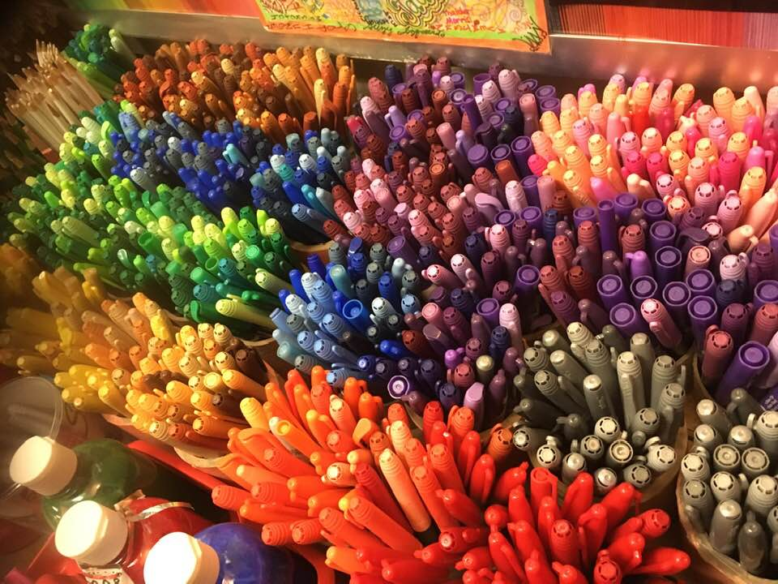
UTA Legal Statements

Institutional Information
UTA students are encouraged to review the below institutional policies and informational sections and reach out to the specific office with any questions. To view this institutional information, please visit the Institutional Information page (https://resources.uta.edu/provost/course-related-info/institutional-policies.php) which includes the following policies among others:
- Drop Policy
- Disability Accommodations
- Title IX Policy
- Academic Integrity
- Student Feedback Survey
- Final Exam Schedule

Face Covering Policy
While the use of face coverings on campus is no longer mandatory, all students and instructional staff are strongly encouraged to wear face coverings while they are on campus. This is particularly true inside buildings and within classrooms and labs where social distancing is not possible due to limited space. If a student needs accommodations to ensure social distancing in the classroom due to being at high risk they are encouraged to work directly with the Student Access and Resource Center to assist in these accommodations. If students need masks, they may obtain them at the Central Library, the E.H. Hereford University Center’s front desk or in their department.

Emergency Exit Procedures
Should we experience an emergency event that requires evacuation of the building, students should exit the room and move toward the nearest exit, which is posted in the classroom. When exiting the building during an emergency, do not take an elevator but use the stairwells instead. Faculty members and instructional staff will assist students in selecting the safest route for evacuation and will make arrangements to assist individuals with disabilities.
All students, faculty and staff are strongly encouraged to subscribe to the MavAlert system that will send information in case of an emergency to their cell phones or email accounts. Anyone can subscribe at Emergency Communication System.

Academic Success Center
The Academic Success Center (ASC) includes a variety of resources and services to help you maximize your learning and succeed as a student at the University of Texas at Arlington. ASC services include supplemental instruction, peer-led team learning, tutoring, mentoring and TRIO SSS. Academic Success Center services are provided at no additional cost to UTA students. For additional information visit: Academic Success Center. To request disability accommodations for tutoring, please complete this form.

The IDEAS Center (https://www.uta.edu/ideas/) (2nd Floor of Central Library) offers FREE tutoring and mentoring to all students with a focus on transfer students, sophomores, veterans and others undergoing a transition to UT Arlington. Students can drop in or check the schedule of available peer tutors at www.uta.edu/IDEAS, or call (817) 272-6593.

The English Writing Center (411LIBR)
The Writing Center offers FREE tutoring in 15-, 30-, 45-, and 60-minute face-to-face and online sessions to all UTA students on any phase of their UTA coursework. Register and make appointments online at the Writing Center (https://uta.mywconline.com). Classroom visits, workshops, and specialized services for graduate students and faculty are also available. Please see Writing Center: OWL for detailed information on all our programs and services.
The Library’s 2nd floor Academic Plaza (http://library.uta.edu/academic-plaza) offers students a central hub of support services, including IDEAS Center, University Advising Services, Transfer UTA and various college/school advising hours. Services are available during the library’s hours of operation.

Librarian to Contact
Each academic unit has access to Librarians by Academic Subject that can assist students with research projects, tutorials on plagiarism and citation references as well as support with databases and course reserves.

Emergency Phone Numbers
Enter the UTA Police Department’s emergency phone number into your own mobile phone.] In case of an on-campus emergency, call the UT Arlington Police Department at 817-272-3003 (non-campus phone), 2-3003 (campus phone). You may also dial 911. Non-emergency number 817-272-3381

Research or General Library Help
Ask for Help
- Academic Plaza Consultation Services (library.uta.edu/academic-plaza)
- Ask Us (ask.uta.edu/)
- Research Coaches (http://libguides.uta.edu/researchcoach)
Resources
- Library Tutorials (library.uta.edu/how-to)
- Subject and Course Research Guides (libguides.uta.edu)
- Librarians by Subject (library.uta.edu/subject-librarians)
- A to Z List of Library Databases (libguides.uta.edu/az.php)
- Course Reserves (https://uta.summon.serialssolutions.com/#!/course_reserves)
- Study Room Reservations (openroom.uta.edu/)

