**[Creativity Tour & Symposium 2025](https://acis.com/tripsite-trip-overview/?key=MjAyNXw3ODYyOQ==)**

**[“Madrid Meet-Up”](https://acis.com/tripsite-trip-overview/?key=MjAyNXw3ODYyOQ==)**

**[Art Education Program](https://acis.com/tripsite-trip-overview/?key=MjAyNXw3ODYyOQ==)**

**Hotel**: [Hotel Sterling](https://www.hotelsterlingmadrid.com/EN/home.html) on C. de San Bernardo, 29, 31, Centro, 28015 Madrid, Spain

**July 10 – Arrival day in Madrid**

Welcome Session – Opening dialogue and orientation led by host presenter Lucy Bartholomee with comments by Keynote speaker Kathy J. Brown. Participants will receive their traveling art supply kit and have a creative prompt to start the program. Walk to dinner. As time allows we will explore the area on a short walking tour.

The Creativity Tour lodging is booked through ACIS and includes breakfast daily and travel insurance, as well as emergency support while we are in Madrid. All other expenses are paid by each individual as we go.

**July 11**

Prado Museum tour with an English guide. (€36) Transportation will either be subway or taxi (costs vary; taxi about €6).

Discussion and creative workshop led by Keynote Speaker Kathy J. Brown. Art materials will be provided in addition to using our traveling art kits.

Evening Art/ography walk led by host presenter Lucy Bartholomee.

**July 12**

[Reina Sofia Museum](https://www.museoreinasofia.es/en/exhibitions/soledad-sevilla) visit. In addition to the famed Guernica by Picasso, this museum is hosting monumental solo exhibits by women artists: Lebanese-born artist Huguette Caland, Spanish artists Laia Estruch and Marisa González. (€15)

Discussion and workshop led by host presenter Lucy Bartholomee, *From the Shadows: The delight and distress of newly re/discovered women artists.*

**July 13**

Keynote presentation and discussion led by Keynote Speaker Kathy J. Brown, *Overlapping Identities: Implications of Mudéjar Architecture in Spain and Beyond.*

Excursion to Segovia by train. (Approx €100.) Highlights of the city include two historic buildings featuring Mudejar architecture: The [Monastery of San Antonio](https://es.wikipedia.org/wiki/Monasterio_de_San_Antonio_el_Real) and [Iglesia de San Millan](https://es.wikipedia.org/wiki/Iglesia_de_San_Mill%C3%A1n_(Segovia)" \t "_blank" \o "https://es.wikipedia.org/wiki/Iglesia_de_San_Mill%C3%A1n_(Segovia)) in addition to fabulous [Roman aqueducts](https://en.wikipedia.org/wiki/Aqueduct_of_Segovia) and the [Alcazar of Segovia](https://en.wikipedia.org/wiki/Alc%C3%A1zar_of_Segovia) castle.

**July 14**

Optional day trip to Cordoba to explore ancient architecture at the Mezquita (2000 years of worship at this site - Roman, Islamic, Christian, contemporary) (€200-300; still looking into options). OR Madrid program will include individual or small group visits to the Royal Palace, Plaza Mayor, Parque del Retiro, and individual choices.

**July 15**

This morning, we will creatively engage with the community through Urban Sketching. Together we will visit iconic sites in Plaza de Espana and Templo de Debod (a park with Egyptian monuments) to draw and paint on site (en plein air) while talking with locals and passers-by. The afternoon is free. This evening, we will meet for a final session led by Lucy Bartholomee with closing comments by Kathy J. Brown before our farewell dinner.

**July 16 – Departure day**

After breakfast today everyone will head home or off to further travel adventures.

[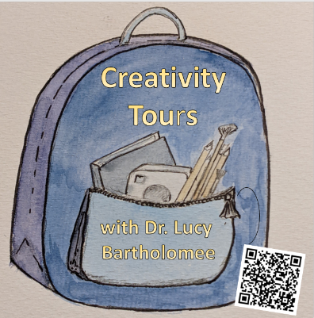](https://www.lucybartholomee.com/creativitytours)